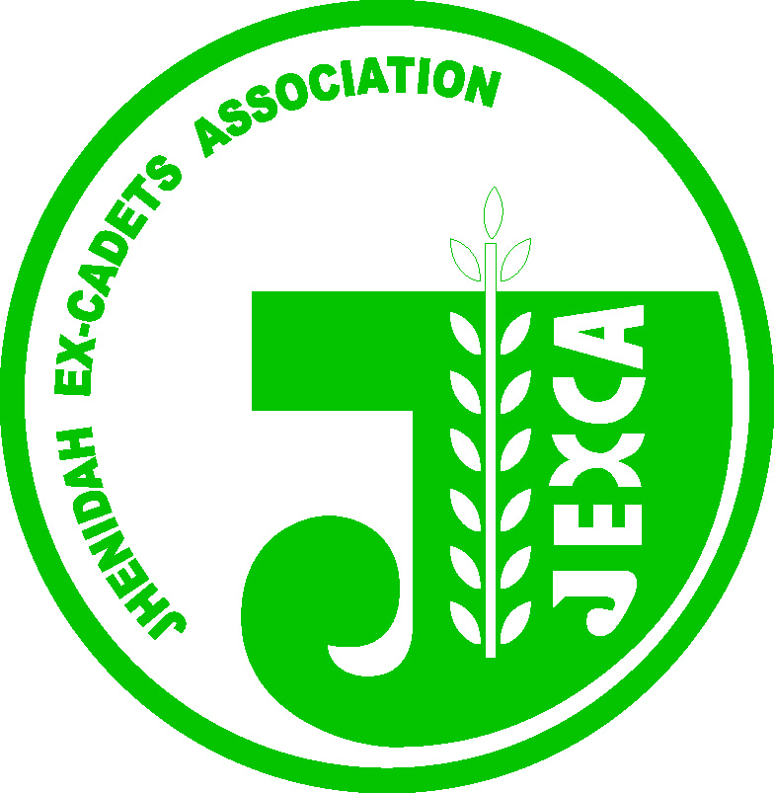
JEXCA
Jhenidah Ex-Cadets Association
R#5, L#5, Planners Tower, 13A Sonargaon Rd, Panthapath, Dhaka-1000,
info@jexca.org.bd, www.jexca.org.bd

08 February 2013

Election of JEXCA New EC 2013-14:
Election Commissioner(s)

Dear Jexcaites:

To conduct JEXCA Election for the year 2013-14, in an EC meeting held on 08 Feb’13, as per the article 55 of JEXCA Constitution, outgoing Executive Committee unanimously nominated:

- Ex-Cadet Air Vice Marshal Mirza A Maruf (Retd) 91/2 as Election Commissioner
- The Election Commissioner may co-opt member/s as deemed necessary.

Please note as per the article 57 of Jexca constitution “For any controversy regarding election the Election Commissioner’s decision shall be the final.

All Executive Committee and JEXCA members are requested to extend their full support to election commissioners to conduct the Jexca Election 2013-14 smoothly.

With best regards

__________________ ______________________
Md.Nasir Uddin Khan Dr.S.M. Mahbubur Rahman
President General Secretary

Copy: Office copy
Air Vice Marshal Mirza A Maruf, Rtd (91/2)

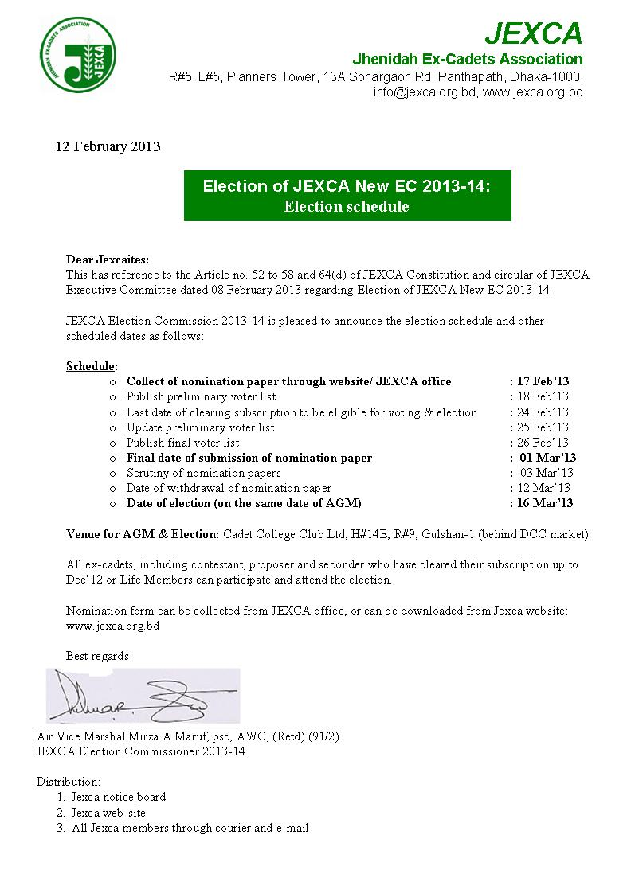

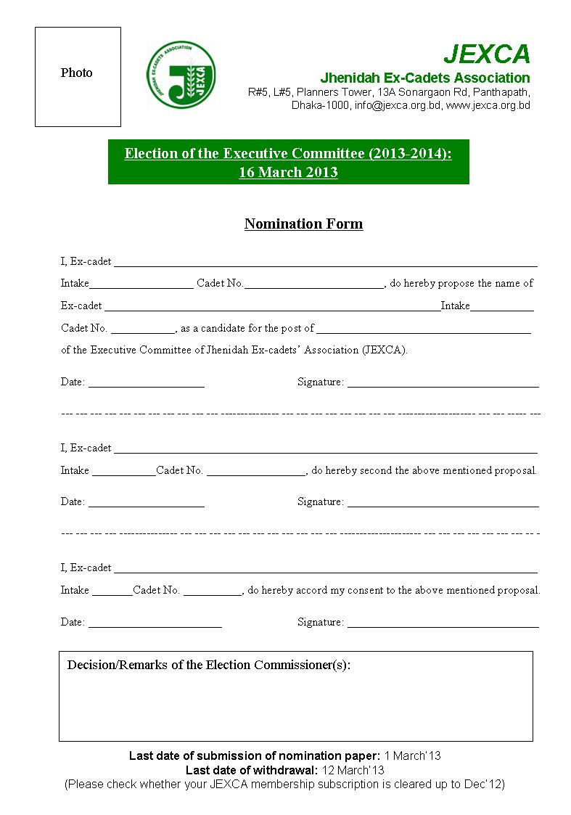

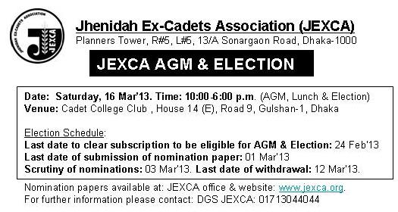

JEXCA
Jhenidah Ex-Cadets Association
R#5, L#5, Planners Tower, 13A Sonargaon Rd, Panthapath, Dhaka-1000,
info@jexca.org.bd, www.jexca.org.bd

Date: 08 February 2013

Notice:
Annual General Meeting 2013 and Election 2013-14

The Annual General Meeting of 2013 of Jhenidah Ex-Cadets Association will be held as per following agenda:

Venue : Cadet College Club Limited, H#14E, R#9, Gulshan-1 (behind DCC market)
Date : 16 March 2013
Time : 10:00 am: Arrival and registration
11:00 am: Annual General Meeting
01:30 pm: Lunch
02:30 pm: Election for the year 2013-14
Agenda:
- Confirmation of the minutes of the AGM held on Friday, 01 July 2011
- Consideration of the Annual Report of the Executive Committee for the year 2011-2012
- Proposals for new Amendments of JEXCA constitution (amendment of the constitution can be proposed by the EC or any Regional Committee provided a notice is given to the EC at least 30 clear days before the AGM along with the proposed amendment).
- Adoption of the Audited Statement of the Accounts for the year 2011-12
- General Secretary’s report
- Appointment of the Auditor(s) and fixation of the remuneration for the Auditor(s) of 2013-14
- Discussion and Question answer
- Any other business allowed by the chair
- Election 2013-14

All members having cleared their respective dues up to 31 Dec’12 by 24 Feb’13 are eligible to attend the AGM 2013 and Election of the JEXCA Executive Committee 2013-14.

__________________ ______________________
Md.Nasir Uddin Khan Dr.S.M. Mahbubur Rahman
President General Secretary

